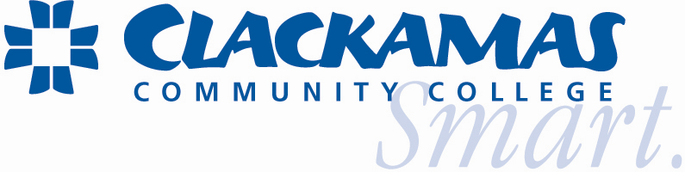
Task Force - Update
Enhancing Student Access to Information Systems

On May 1, 2007, Presidents Council authorized a task force to develop a plan that ensures the college compliance with the Communications Assistance for Law Enforcement Act (CALEA); the implementation of a Portal; and provide students with college supplied email accounts. This report provides the task force findings and a set of recommendations to follow in the design and implementation of these systems.

Some of the Motivating Factors for Expanding Online Services to Students
Students expect colleges to offer comparable online services that they experience in their personal lives. Among those expectations include:
Self-service options
Both younger and older generation’s of students want systems that enable them to serve themselves.
Personalization of web services
Students want to be recognized as individuals and have the ability to personalize their web service to their specific needs and interests.
Clackamas is not alone in its challenges to keep pace with student demands for additional online capabilities. While some of these demands are driven by technology itself, many are driven by students’ exposure to other online systems. The solution for many of these needs lie in the application of new technologies on a college-wide level. Students want access to information and do not want to be burdened by the lack of integration between systems, the frustration of learning how to navigate between systems or the requirement of multiple logins or passwords.
The Task Force surveyed 230 students and asked them: What web sites to you visit on a regular basis?
The chart below represents their responses.

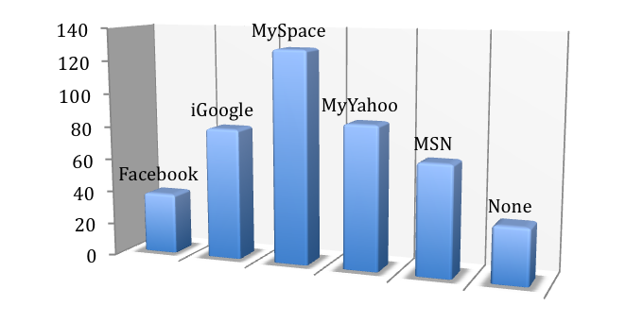
Task Force Participants
Javier Montero | ASG Student Representative
Terry Mackey | Department Chair, Library
Stephen Brouwers  Stuart Long  Scott Branscum  Dean Walch  Ariane Amstutz  Polly Schultz  Kim Carey  Diane Drebin | ITS Software Specialist  ITS Lead, Systems Analyst  ITS System Engineer  ITS Web Coordinator  Student Advising and Recruiting  Part-time Faculty  ITS Director, Admin. Computing  Dean, Enrollment Services
Bill Zuelke | Dean, Student Services
Tara Sprehe | Registrar
Joe Austin | Dean, ITS and Task Force Chair
Expanded Task Force Members Includes
Sarah Nolan | Library
Andy Mingo | Full-time Faculty
Anne Bachmann | Full-time Faculty
Useni Makano | ASG Student Representative
Shawn Swanner | ITS Web Developer
Task Force Recommendations
- Expand the scope of the task force to include the implementation of the recommendations outlined in the final report.
- Ensure full compliance with the Communications Assistance for Law Enforcement Act (CALEA).
- Adopt and implement the Datatel Active Campus Portal for students, staff and alumni.
- Provide college supplied student email accounts.
- Migrate from Novell and GroupWise to Microsoft Exchange Email System
- Increase staffing in the ITS department by 2.0 FTE to administer and support the Portal and student email systems.
- Empower the Web Committee to coordinate the overall design layout, content and usability of the Portal.
Coming Soon… (June 2008)

Microsoft Live@edu
Student Email


Microsoft Live@edu provides a simple, practical way to provide advanced online communications and collaboration for students and alumni. At no cost, Microsoft provides students with:
- hosted email
- 5 GB free storage space
- 10 MB attachments
- calendars
- online workspaces
- mobile alerts
- document sharing
- instant messaging
- blogs
The email system will be branded with the CCC logo and Internet domain name (Clackamas.edu) .All advertising will be suppressed. Student accounts are retained for 1-year after graduation. After that accounts can be rolled into an Alumni status.
Student Support Provided

Microsoft offers representatives available to respond to student support queries via the Web.
Hours of operation: 24 hours a day, 7 days a week, 365 days a year
Institutional Support Provided
Microsoft Live@edu customers receive complimentary online provisioning and deployment support as well as 24x7 telephone support for critical issues.

Coming Soon… (Fall term 2008)

Datatel
Active Campus Portal


Easy access to information
The Active Campus Portal provides a gateway to all resources a user might need, free from the hurdles traditionally associated with multi-layered and diverse campus environments. Users have fingertip access to critical data, whenever they need it — so they can take advantage of convenient self-service opportunities, or provide greater support to others.

The ActiveCampus Portal provides extremely tight integration to every function with the Datatel® Colleague® enterprise resource planning (ERP) system, as well as single sign-on access to 3rd party applications and reporting tools. There is no need to launch individual programs, or search for the location of specific data. Instead of spending time jumping
between multiple systems, databases, and screens, users spend more time collaborating and making better use of their time and resources — meaning fewer unproductive meetings, fewer confusing e-mails, and lower administrative expenses


